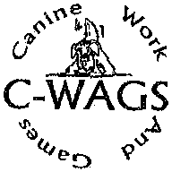
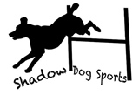

EVERTHING YOU NEED TO KNOW ABOUT CWAGS OBEDIENCE AND RALLY
Saturday, June23 9:00am GCOC Training Building
$10 to GCOC Members
9:00 Presentation of Rules
10:00 Demonstration of Obedience Levels
Followed by Run Throughs (1 per participant)
Followed by Demonstration of Rally
Followed by Rally Run Throughs (1 per participant)
Extra Run Throughs will be allowed at $5.00 per run if time allows

Don’t Forget
We will have a CWAGs trial at our building on July 14-15. If you haven’t tried CWAGs. June 23rd is your opportunity to get familiar with the rules and the exercises. It is a great first venue. The judges are friendly, and exhibitors are relaxed, and the dogs get TREATS in the ring.

