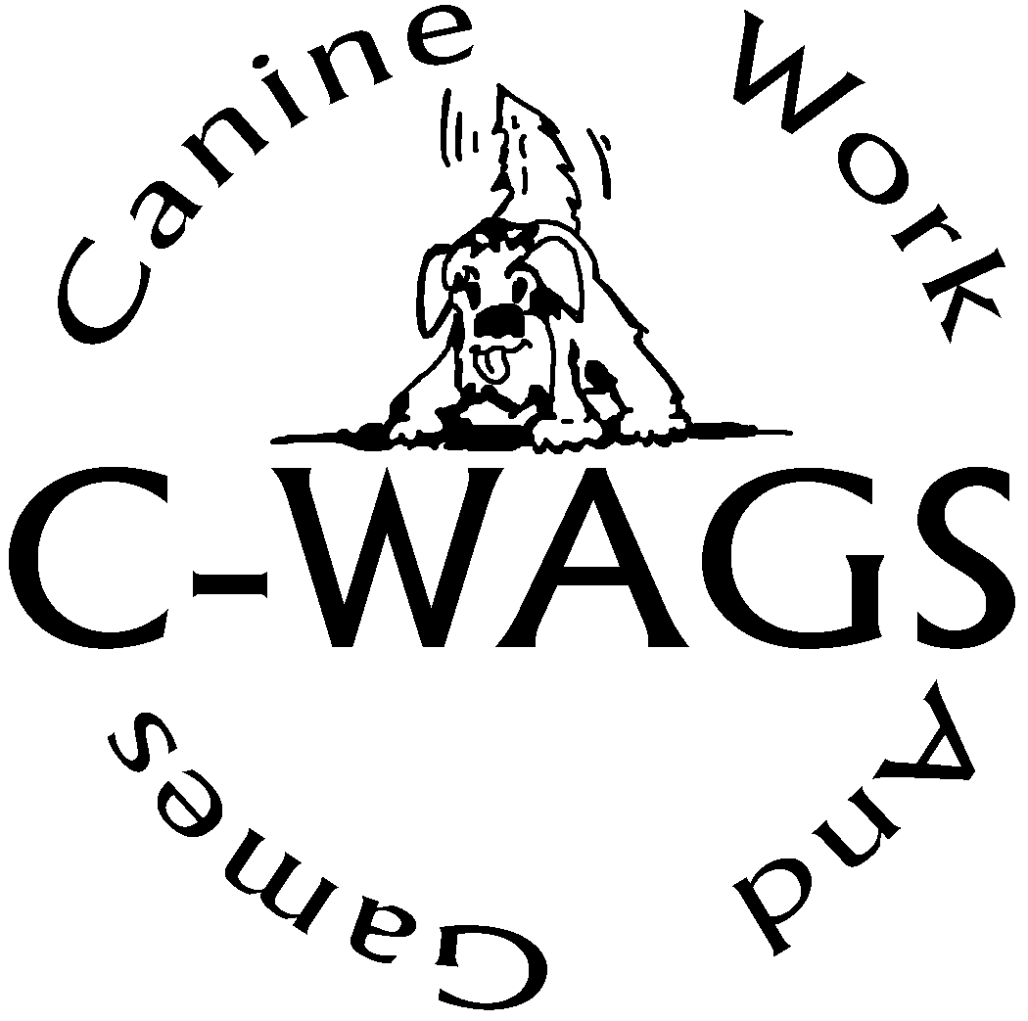

Jump Height Modification Request

It is recommended that exhibitors complete a Jump Height Modification Request and submit to the Trial Secretary with the entry form.

This Form Covers the Entire Trial

Handler’s Name:

Dog’s Name:

Reason for request:

Highlight or circle Jump Height Requested: 0” 4” 8” 12”

Typing your name counts as your signature.

For Online Entries you will be able to upload this when you check Yes this is modified Jump Height.

