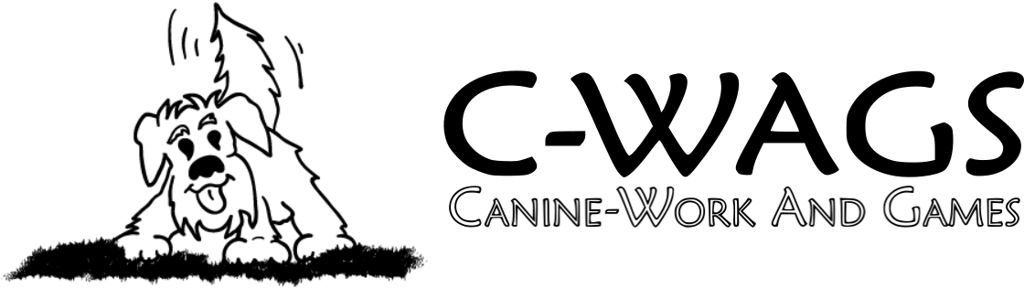**.**

**Rally League Play**

Hosted By:



**SHADOW DOG SPORT**

Open to all dogs of any breed – Including “All Americans”!

Handlers and Dogs with Disabilities Welcome

At the Greater Columbia Obedience Club

947 S. Stadium Road Suite #10

Columbia, SC 29201

Indoor trial, rubber matting

|  |  |  |
| --- | --- | --- |
| **Date** | **Time** | **Classes** |
| Friday, February 23 | 6-9 PM | Advanced Rally  Zoom 1.5 Rally |
| Friday, March 1 | 6 – 9 PM |
| Friday, March 8 |
| Friday March 15 |
| Friday, March 29 |

League registration allows you to attend any and all league trials days for a single price. Advance registration is preferred and will be limited to 20 dogs per class.

*These are sanctioned events under Canine – Work And Games, LLC

For complete rules go to [www.c-wags.org](http://www.c-wags.org)

Judges and C-WAGS Advocates:

Nicole Tate – Blythewood, SC

Nell Jenkins – Columbia, SC

Robbie Black – Columbia, SC

Trial Chair and Secretary

Carolyn Royall - candcroyall@gmail.com

Justine Borghello - Info@smokeyoaksk9.com

**Entry Process**

Pre-registration and payment must be received by February 21, 2024.

[Online registration and payments are preferred](https://www.gcoc.net/sys/website/system-pages/?pageId=1819436)

If the trial is not full on-line entries will continue to be available.

Mailed entries must be postmarked by February 17, 2024 or received by February 21, 2024. Entries submitted via Federal Express or Express Mail will be accepted only if the signature waiver is signed. No telephone, e-mail, or fax entries will be accepted. Any changes to entries, including cancellations, will be accepted until 6pm 2/21/2024. Changes must be made to the Secretary by telephone, e-mail, or in writing. Cancellations received after 2/21/2024 will not be eligible for a refund of fees.

All dogs must be registered with C-WAGS to participate and receive credit in the C-WAGS classes. C-WAGS registration is $15 and can be completed here: [www.c-wags.org/dog-registration/online-registration](http://www.c-wags.org/dog-registration/online-registration)

**League Details**

Each registered team will get the chance to complete one run in each class per day in a mini trial setting. Each qualifying run will count towards your title!

During league times you will get the opportunity to practice rally skills, socialize with other members, and dinner will be provided!

If you are entering multiple dogs, register each dog separately. If your dog completes their title during the league, you will be allowed to switch classes/division.

**Awards**

Qualifying Ribbons for every qualifying run.

New Title Ribbons will be awarded to those earning their fourth qualifying score.

Placement ribbons (1st through 4th) will be awarded for Advance and Zoom 1.5 classes on the last night of the league. Placement score will be based on each team’s average of their 4 highest scores for the class and division.

If you expect to receive an advanced title (ACE or Master Team Award), please indicate this on your registration so we can make sure to have a ribbon for you.

**Accommodations**

*Please call to confirm dog policy.*

Econo Lodge Inn & Suites

1935 Airport Blvd, Cayce, SC 29033•(803) 936-0015

LaQuinta Inn and Suites, 7333 Garners Ferry Road, Columbia, SC 29209 (I-77 Exit 9A) to make reservation call 803-783-5410. Breakfast; micro and refrigerator in all rooms.

Please have your canine companions on their best behavior, so these hotels will want our business again. And, as always, clean up after your dogs!

OFFICIAL C-WAGS ENTRY FORM

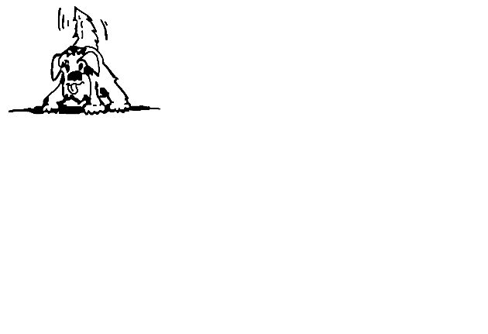***2/23, 3/1, 3/8, 3/15, and 3/29 - 2023***

**Online registration is preferred** [**Click here to register and pay online!**](https://www.gcoc.net/sys/website/system-pages/?pageId=1819436)

Make entry fees payable to: **Shadow Dog Sports**

Mail Entries to: Justine Borghello **–** 892 Mason Dickson Rd; York, SC 29745

### ENTRY INFORMATION – Circle one class and one division

|  |  |
| --- | --- |
| **Class (select only 1)** | **Division (select only 1)** |
| Advanced Rally | A |
| Zoom 1.5 | B |

(enter “A” if your dog does not have a title in that level or equivalent in another venue)

|  |  |  |  |  |
| --- | --- | --- | --- | --- |
| Handler using wheelchair? | No | Manual | | Electric |
| Jr Handler? | No | | Yes | |
| GCOC Member? | No | | Yes | |

Do you expect to receive an advanced title? List it here: _____________

Entry Fee: $60 per team per class with GCOC membership

$75 per team per class without GCOC membership

**Total fees enclosed _________**

This entry is not valid unless the disclaimer has been completed, signed and dated. In order to be valid, entries must also be received with correct fees by the closing date at the address provided.

**Attach Dog/Handler Registration** below **or** enter information if you have not yet received registration back:

Reg. Name_________________________________________ Breed_________________

Call Name _____________________________Reg. No. ___________________________

Owner’s Name ____________________________________________________________

Address _________________________________________________________________

City _________________________________ State __________ Zip _________________

Phone ____________________ Email _________________________________________

DISCLAIMER – MUST BE SENT WITH ENTRY

I/we acknowledge that I am/we are familiar with the current rules applying to Canine-Work And GameS Trials. I/we agree that the Host Club holding the Trial has the right to refuse entry for cause which the Host Club shall deem to be sufficient. Upon acceptance of this entry, I/we agree to hold Canine-Work And GameS, LLC, and its members and officers, this Host Club, its members, directors, officers, agents, show secretary, show chairperson, show committee and the owner or lessor of the premises and any employees of the aforementioned parties, any sponsors of this event, harmless from any claim or loss or injury which may be alleged to have been caused directly or indirectly to any person or thing by the act of this dog or handler while in or upon the show trial premises or grounds or near any entrance thereto, and I/we further agree to hold the fore mentioned parties harmless from any claim or loss of this dog by disappearance, theft, death or otherwise, and from any claim for damage or injury to the dog, whether any claim be caused or alleged to be caused by the negligence of the Host Club or any of the parties aforementioned, or by the negligence of any other person, or any other cause or causes. I/we hereby assume sole responsibility for and agree to indemnify and save the aforementioned parties harmless from any and all loss and expense (including legal fees) by reason of the liability imposed by law upon any of the aforementioned parties for damage because of bodily injuries, including death at any time resulting there from, sustained by any person or persons, including myself/ ourselves or on account of damage to property, arising out of or in consequence of my/our participation in the Trial, howsoever such injuries, death or damage to property may be caused and whether or not the same may have been caused by negligence of the aforementioned parties or any of their employees or agents, or any other persons.

THIS DISCLAIMER MUST BE SIGNED AND INCLUDED FOR A VALID ENTRY

I/we agree to abide by the rules of C-WAGS currently in effect at the time of the trial. I/we testify that the dog entered is healthy and vaccinated or titered. I/we certify that the dog entered is not dangerous to any person or other dog. By signing below, I/we agree to the disclaimer on this entry form.

**______________________________________ _______________**

Signature – Owner or Parent / Guardian if Minor Date

*Entry form MUST be signed and the Disclaimer MUST be attached for a valid entry.*

|  |
| --- |
| Team Registration Form |
| Handler Owner Name: |
| (If Jr. Handler provide parent name, contact info if different) |

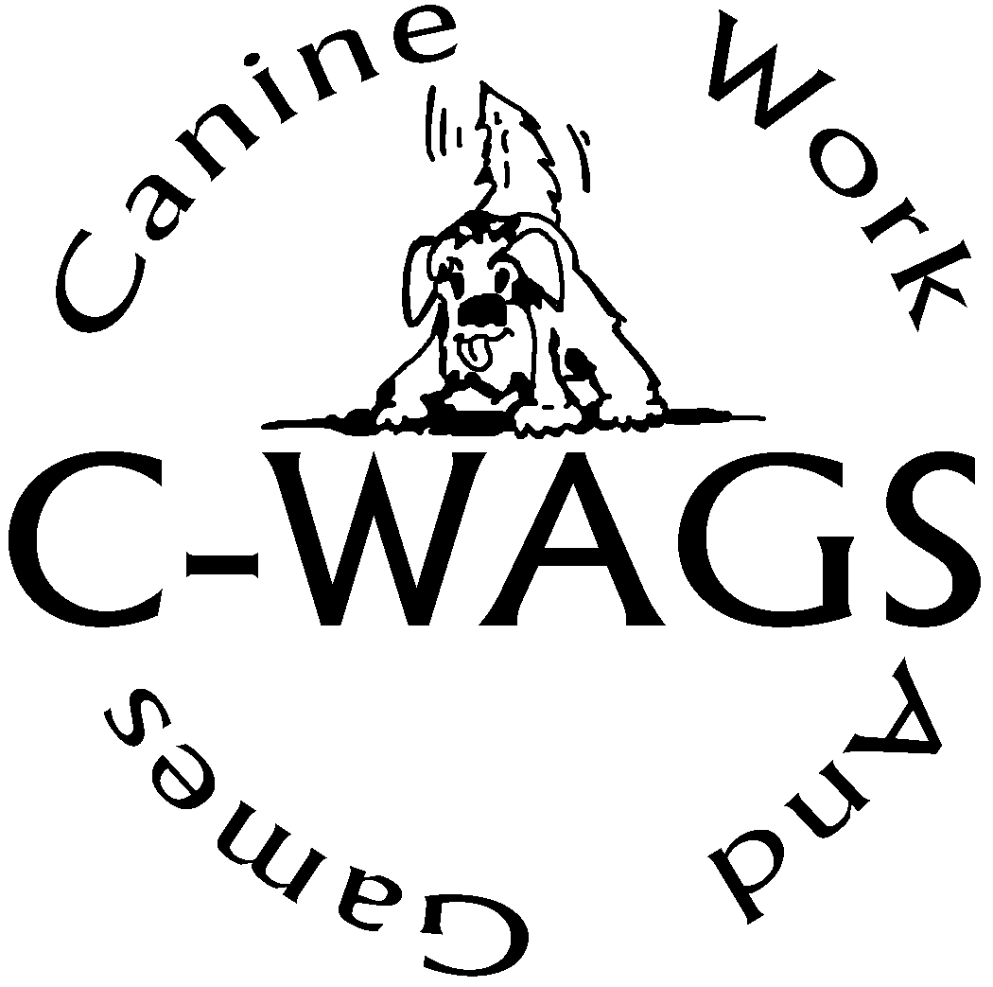

**C- W**

**A**

**G**

Canine Work & GameS

|  |  |
| --- | --- |
| Owner’s Reg. Number if previously registered : | |
| Address: | |
| City, State,Zip: | |
| Telephone: | Jr. Handler Birthdate: |
| Email: | |
| Dog’s Formal  Name: | |
| *(Name to appear on title certificates, please print clearly or type)* | |
| Call Name: | Birth date |
| Breed: | |

Fees:

Owner and First Dog Registration $15.00

Jr. Handler Or Additional Dog: $ 8.00

Please make check or money order (U.S funds only) payable to

C-WAGS and mail with completed registration to:

C-WAGS Shirley Ottmer

3693 Fairview Ave, Jackson, MI 49203

You must register your dog with C-WAGS in order to compete and receive credit in a C-WAGS sanctioned event. Please complete a separate registration for each dog you are registering. A registration number will be emailed to you. If you do not have an email address, it will be mailed. Please allow 2 weeks for processing registrations that include an email address, 3-4 weeks for regular mail.

--- A copy of your dog’s registration should be furnished to trial host each time you enter. -----

**C-WAGS Notice to Exhibitors**

Competitors, through submission of entry, acknowledge that they are knowledgeable of C-WAGS Obedience & Rally rules and regulations including but not limited to the following rules regarding entry:

* All exhibitors are expected to treat the judges, trial hosts, your canine partner and all other exhibitors with respect.
* All judges and trial hosts are expected to show respect to all exhibitors.
* This trial is open to all dogs registered with C-WAGS.
* Trial Hosts may elect to accept FOR EXIBITION ONLY entries of non-registered dogs.
* Teams may be entered in multiple levels/classes at the same trial.
* Dogs must be shown by a member of the owner’s immediate family.
* Collars: The dog must wear a flat type collar (buckle, snap or proper fit martingale) and/or body harness in the ring. Electronic training collars are not allowed on the show grounds.
* Owners with disabilities are encouraged to compete. Any necessary modifications to the exercises must be provided by the handler to the judge and approved by the judge
* Safety shall always be of foremost consideration in actions and conduct by handlers at all times. Handlers, through entry at this event, accept full responsibility for themselves and the actions of their dogs.

In addition,

* The organizing committee may refuse any entry for any reason.
* THERE SHALL BE NO REFUND for entries in the event a dog and/or handler are dismissed from competition, regardless of reason for such dismissal. There will be no refunds if the trial has to be cancelled for any reason.
* Refunds will be made for females in season upon written request accompanied by a statement from the exhibitor’s veterinarian.
* Returned checks do not constitute a valid entry. There will be a $25.00 service charge for returned checks. Payment of entry fees and service charges shall be made by money order within 7 days of notice to exhibitor of returned check. Any fees not received within 7 days of notice result in cancellation of event results for all classes for the registration number(s) of delinquent entry/entries. No reinstatement of results is possible.
* All competitors through entry at this event waive any and all rights relative to video broadcast of this event. Competitors shall have the right to videotape portions of this event for their personal use only. No portion of this event may be videotaped for commercial or other purposes.
* Dogs must be on leash while on show grounds unless being shown.