GCOC Halloween Carnival

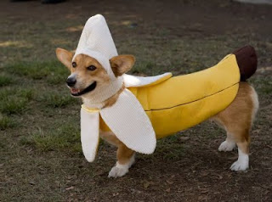

An afternoon of fun and games for dogs and their people
for GCOC members
Sunday, October 29, 2017
3 pm to 5 pm
Cost: $7.00 for unlimited games and contests.
Pre-register on line by October 25
$10.00 for day of Carnival registration
Prizes, Photos, Fellowship and Fun
Activities will include: Costume Contest, Tricks Contest, Musical Hula Hoops, Popcorn Catching Contest, Temptation Tower, Obstacle Course, Recall Races, Muffin Tin Game, Peanut Butter Race and more.
This event is open to all GCOC members and their invited guests. 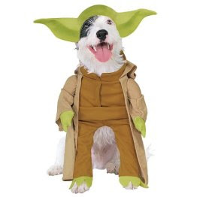
Volunteers Needed:
Friday September 15—Set up for Seminar and Rally Run-Thrus
1.
2.
3.
4.
Sunday September 17—Help set courses and “steward”
1.
2.
3.
4.
Sunday October 29, 10am-12noon--Decorate and set up for Halloween Carnival
1.
2.
3.
4.
5.
Sunday October 29, 10am-12noon—Help with Games
1.
2.
3.
4.

